1. **INTRODUCTION**
   1. *overview*
      * *Description of the project*

Project Description:

Fashion Haven, an online retail store, leverages Zoho Books to manage their inventory and track sales. They can generate invoices and manage customer payments seamlessly. Zoho Books also enables them to reconcile bank transactions and generate financial reports, helping them make informed decisions about their business..

Fashion Haven is a Private Limited company also registered under GST in Tamil Nadu. Fashion Haven is a retailor of various lifestyle products in wholesale and retail, it has a wide range of customers (B2B & B2C) all over the state and it procures from various suppliers in the state. It operates at a Gross Profit margin of 50%.

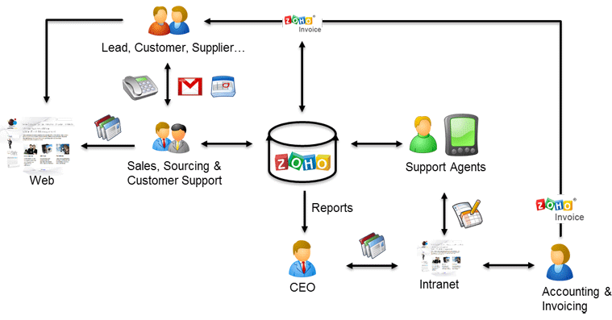

.

1. **Problem definition & design Thinking**
   1. *Empathy map*

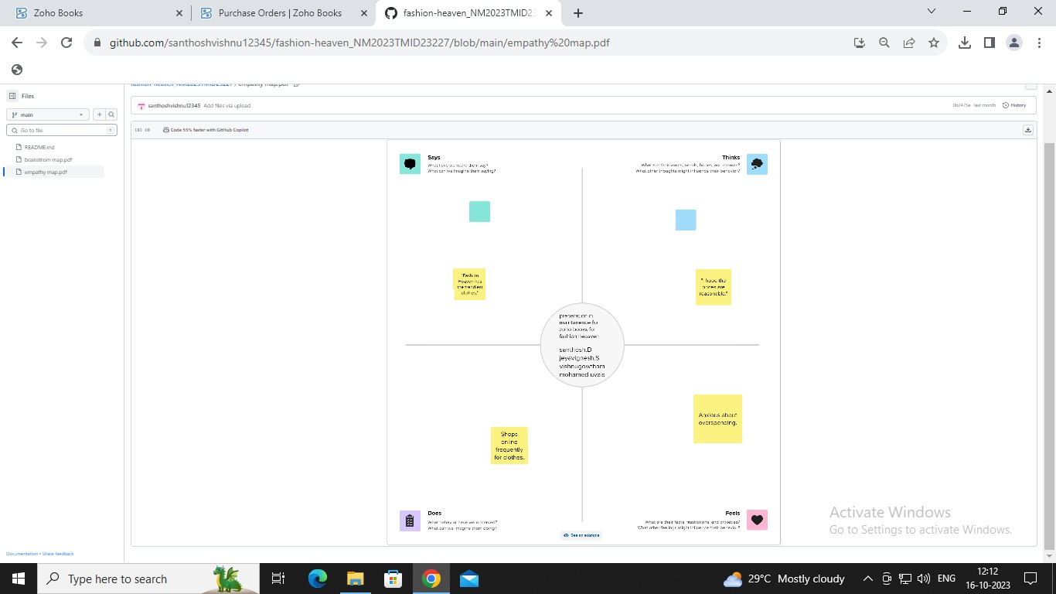

* 1. *Ideation & Brainstorming map*

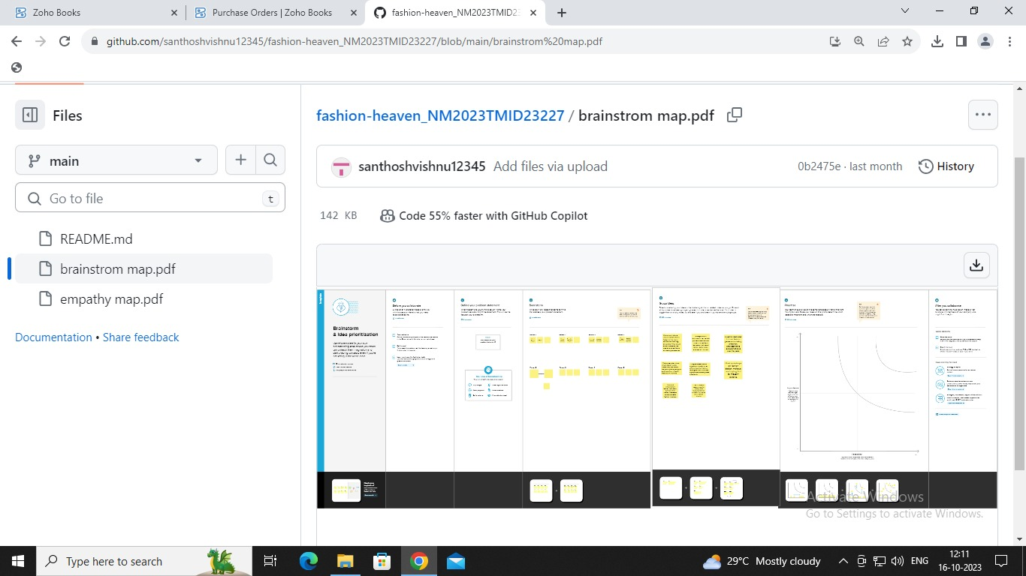

1. **Result Profit&loss**

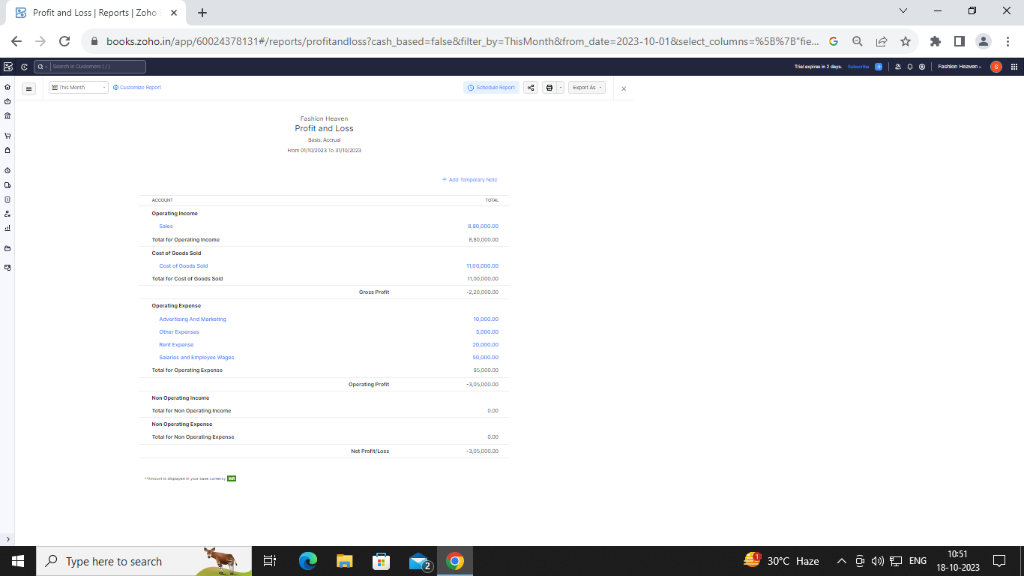

Balance sheet:

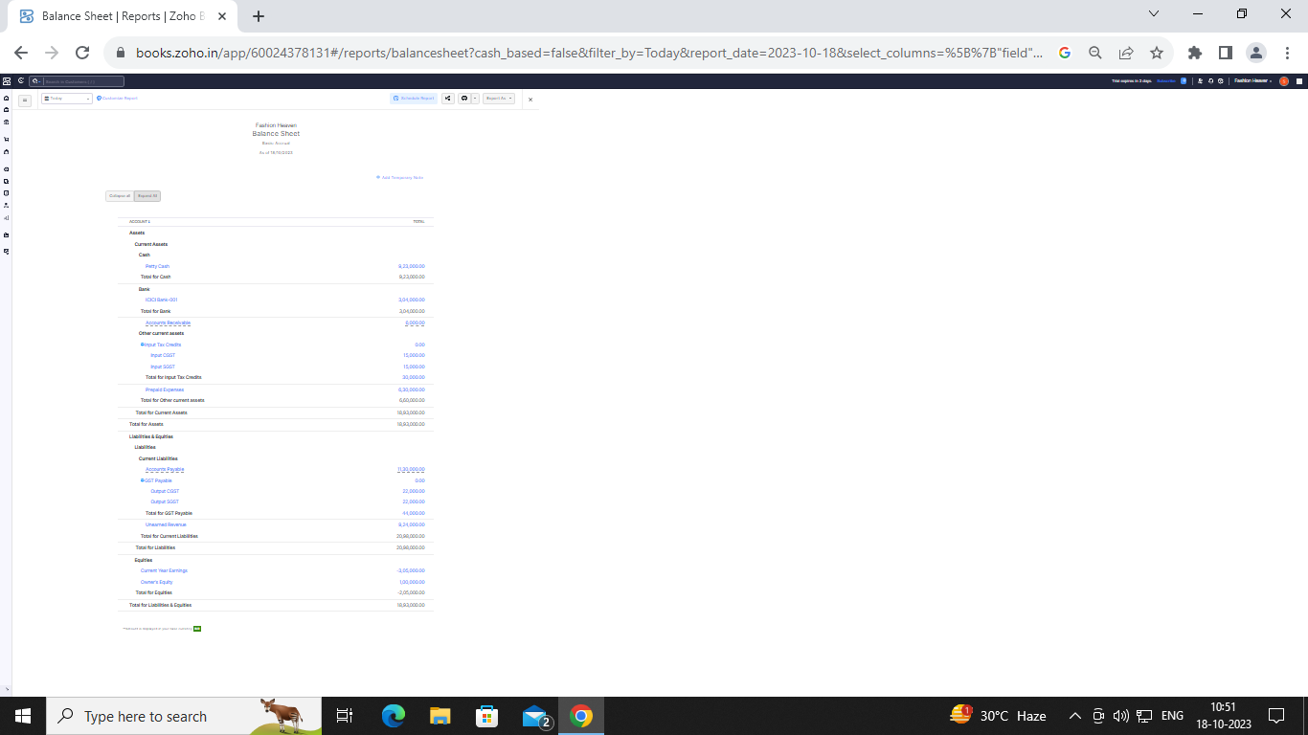

Purchase order:

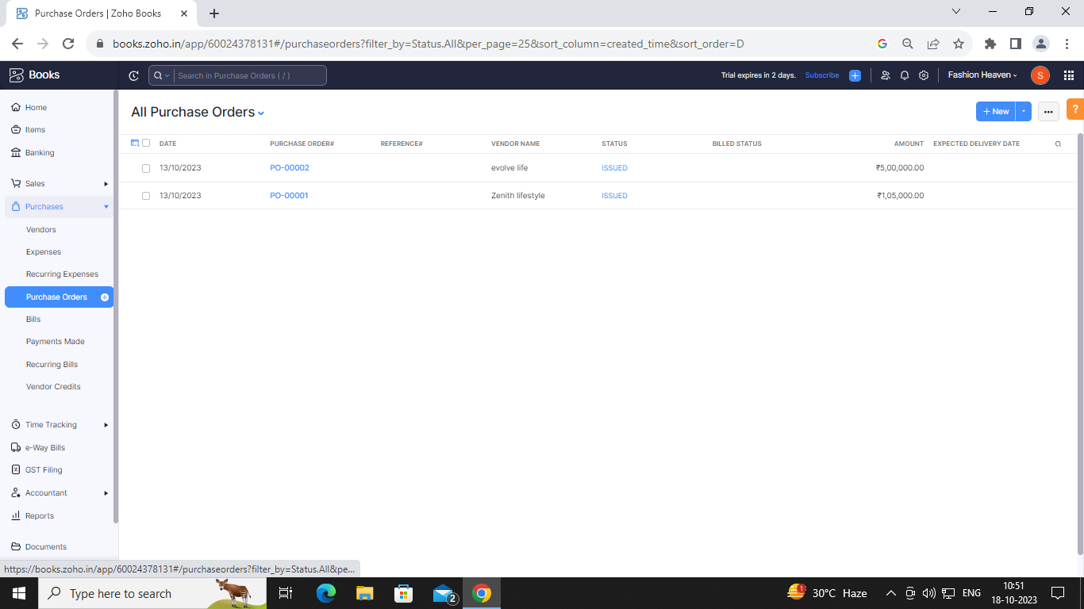

Invoice:

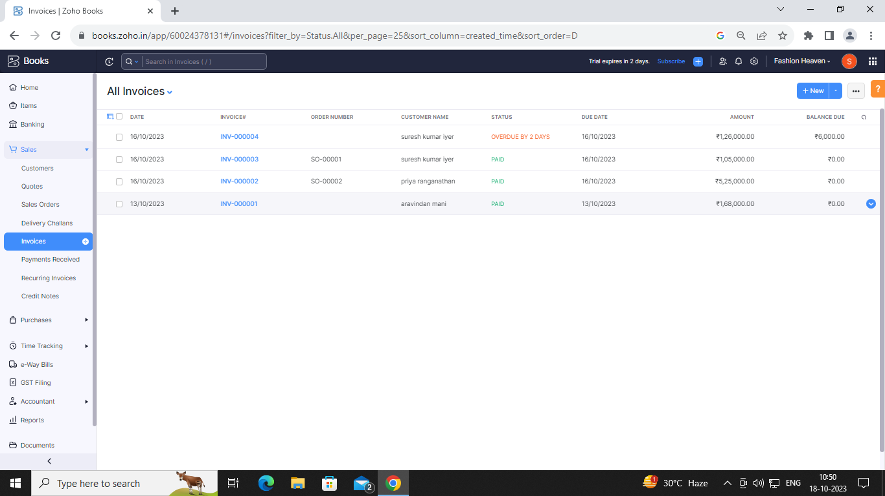

Bills:

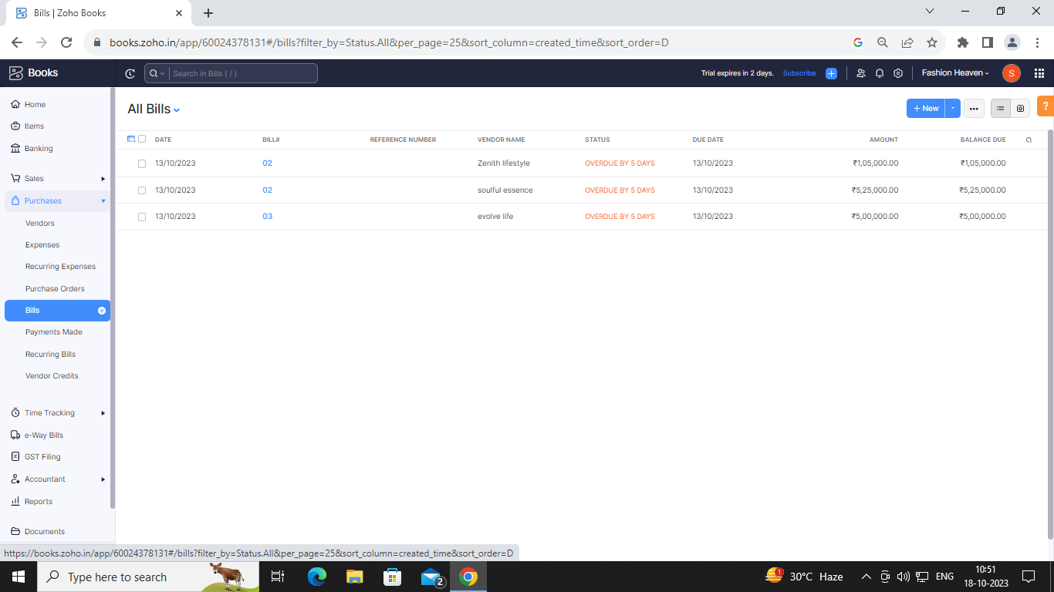

ADVANTAGES OF fashion heaven:

Fashion is more than just some clothes and accessories. Every woman wants and deserves to look nice and dress well. Not only because it would present her in a good light in a social setting, but also because it is fulfilling, mood-boosting and imperative for self-esteem.

There are also many benefits that come along with finding your personal style:

Confidence boost

Sense of accomplishment

Consistent wardrobe

DISADVANTAGES OF HEALTHHUB MEDICAL CLINIC:

Pressure to Conform: Fashion trends can create social pressure to conform, leading to a lack of individuality and self-expression. Body Image Concerns: Some trends may not be inclusive of all body types, leading to body image issues and self-esteem issues. Ethical Concerns: Many fashion tr..

1. *APPLICATIONS:*

Fashion heaven

1. **Conclusion:**

 fashion design is a constantly evolving field that provides opportunities to express personal style and unique idea.

1. **FUTURE SCOPE:**

Only a select few people in India possess the imagination and courage to pursue a profession in fashion design. If you are one of those select few, you are in for some wonderful opportunities..

1. **APPENDIX:**

<https://github.com/santhoshvishnu12345/fashion-heaven_NM2023TMID23227>

|  |
| --- |
|  |
| <!DOCTYPE html> |
|  | <html lang="en" data-color-mode="auto" data-light-theme="light" data-dark-theme="dark" data-a11y-animated-images="system" data-a11y-link-underlines="false"> |
|  |  |
|  | <style> |
|  | /* for each iteration, uncomment the CSS variable */ |
|  |  |
|  | /* light themes */ |
|  | [data-color-mode="light"][data-light-theme*="light"], |
|  | [data-color-mode="auto"][data-light-theme*="light"] { |
|  | /* iteration 1 */ |
|  | --border-color-iteration-1: #C8CCD0; |
|  | /* iteration 2 */ |
|  | --border-color-iteration-2: #BABFC5; |
|  | /* iteration 3 */ |
|  | --border-color-iteration-3: #A6ADB4; |
|  | /* iteration final */ |
|  | --border-color-iteration-4: #868F99; |
|  |  |
|  | /* the first value is the final step, which falls back to previous iterations */ |
|  | --control-borderColor-rest: var(--border-color-iteration-4, var(--border-color-iteration-3, var(--border-color-iteration-2, var(--border-color-iteration-1)))) !important; |
|  | } |
|  |  |
|  | /* dark themes */ |
|  | [data-color-mode="dark"][data-dark-theme*="dark"], |
|  | [data-color-mode="auto"][data-light-theme*="dark"] { |
|  | /* iteration 1 */ |
|  | --border-color-iteration-1: #363940; |
|  | /* iteration 2 */ |
|  | --border-color-iteration-2: #3F434B; |
|  | /* iteration 3 */ |
|  | --border-color-iteration-3: #4B5159; |
|  | /* iteration final */ |
|  | --border-color-iteration-4: #666E79; |
|  |  |
|  | /* the first value is the final step, which falls back to previous iterations */ |
|  | --control-borderColor-rest: var(--border-color-iteration-4, var(--border-color-iteration-3, var(--border-color-iteration-2, var(--border-color-iteration-1)))) !important; |
|  | } |
|  |  |
|  | [data-color-mode="dark"][data-dark-theme="dark_dimmed"], |
|  | [data-color-mode="dark"][data-dark-theme="light_high_contrast"], |
|  | [data-color-mode="dark"][data-dark-theme="dark_high_contrast"], |
|  | [data-color-mode="light"][data-light-theme="dark_dimmed"], |
|  | [data-color-mode="light"][data-light-theme="light_high_contrast"], |
|  | [data-color-mode="light"][data-light-theme="dark_high_contrast"] { |
|  | /* skip these themes, use the fallback */ |
|  | --control-borderColor-rest: initial !important; |
|  | } |
|  |  |
|  | @media (prefers-color-scheme: dark) { |
|  | /* dark colors in dark mode */ |
|  | [data-color-mode="auto"][data-dark-theme*="dark"] { |
|  | /* iteration 1 */ |
|  | --border-color-iteration-1: #363940; |
|  | /* iteration 2 */ |
|  | --border-color-iteration-2: #3F434B; |
|  | /* iteration 3 */ |
|  | --border-color-iteration-3: #4B5159; |
|  | /* iteration final */ |
|  | --border-color-iteration-4: #666E79; |
|  |  |
|  | /* the first value is the final step, which falls back to previous iterations */ |
|  | --control-borderColor-rest: var(--border-color-iteration-4, var(--border-color-iteration-3, var(--border-color-iteration-2, var(--border-color-iteration-1)))) !important; |
|  | } |
|  |  |
|  | /* light colors in dark mode */ |
|  | [data-color-mode="auto"][data-dark-theme*="light"] { |
|  | /* iteration 1 */ |
|  | --border-color-iteration-1: #C8CCD0; |
|  | /* iteration 2 */ |
|  | --border-color-iteration-2: #BABFC5; |
|  | /* iteration 3 */ |
|  | --border-color-iteration-3: #A6ADB4; |
|  | /* iteration final */ |
|  | --border-color-iteration-4: #868F99; |
|  |  |
|  | /* the first value is the final step, which falls back to previous iterations */ |
|  | --control-borderColor-rest: var(--border-color-iteration-4, var(--border-color-iteration-3, var(--border-color-iteration-2, var(--border-color-iteration-1)))) !important; |
|  | } |
|  |  |
|  | [data-color-mode="auto"][data-dark-theme="dark_dimmed"], |
|  | [data-color-mode="auto"][data-dark-theme="light_high_contrast"], |
|  | [data-color-mode="auto"][data-dark-theme="dark_high_contrast"] { |
|  | /* skip these themes, use the fallback */ |
|  | --control-borderColor-rest: initial !important; |
|  | } |
|  | } |
|  |  |
|  | @media (prefers-color-scheme: light) { |
|  | /* dark colors in light mode */ |
|  | [data-color-mode="auto"][data-light-theme*="dark"] { |
|  | /* iteration 1 */ |
|  | --border-color-iteration-1: #363940; |
|  | /* iteration 2 */ |
|  | --border-color-iteration-2: #3F434B; |
|  | /* iteration 3 */ |
|  | --border-color-iteration-3: #4B5159; |
|  | /* iteration final */ |
|  | --border-color-iteration-4: #666E79; |
|  |  |
|  | /* the first value is the final step, which falls back to previous iterations */ |
|  | --control-borderColor-rest: var(--border-color-iteration-4, var(--border-color-iteration-3, var(--border-color-iteration-2, var(--border-color-iteration-1)))) !important; |
|  | } |
|  |  |
|  | /* light colors in light mode */ |
|  | [data-color-mode="auto"][data-light-theme*="light"] { |
|  | /* iteration 1 */ |
|  | --border-color-iteration-1: #C8CCD0; |
|  | /* iteration 2 */ |
|  | --border-color-iteration-2: #BABFC5; |
|  | /* iteration 3 */ |
|  | --border-color-iteration-3: #A6ADB4; |
|  | /* iteration final */ |
|  | --border-color-iteration-4: #868F99; |
|  |  |
|  | /* the first value is the final step, which falls back to previous iterations */ |
|  | --control-borderColor-rest: var(--border-color-iteration-4, var(--border-color-iteration-3, var(--border-color-iteration-2, var(--border-color-iteration-1)))) !important; |
|  | } |
|  |  |
|  | [data-color-mode="auto"][data-light-theme="dark_dimmed"], |
|  | [data-color-mode="auto"][data-light-theme="light_high_contrast"], |
|  | [data-color-mode="auto"][data-light-theme="dark_high_contrast"] { |
|  | /* skip these themes, use the fallback */ |
|  | --control-borderColor-rest: initial !important; |
|  | } |
|  | } |
|  | </style> |
|  |  |

<link crossorigin=”anonymous” media=”all” rel=”stylesheet” href=”./NM2023TMID22539_profit_and_loss.pdf at main · asmku643mku643c1c31260_NM2023TMID22539 · GitHub_files/light-b92e9647318f.css”><link crossorigin=”anonymous” media=”all” rel=”stylesheet” href=”./NM2023TMID22539_profit_and_loss.pdf at main · asmku643mku643c1c31260_NM2023TMID22539 · GitHub_files/dark-5d486a4ede8e.css”><link data-color-theme=”dark_dimmed” crossorigin=”anonymous” media=”all” rel=”stylesheet” data-href=https://github.githubassets.com/assets/dark_dimmed-27c8d635e4e5.css><link data-color-theme=”dark_high_contrast” crossorigin=”anonymous” media=”all”

rel=”stylesheet”

data-href=https://github.githubassets.com/assets/dark_high_contrast-8438e75afd36.css><lin k data-color-theme=”dark_colorblind” crossorigin=”anonymous” media=”all” rel=”stylesheet” data-href=https://github.githubassets.com/assets/dark_colorblind-bf5665b96628.css><link data-color-theme=”light_colorblind” crossorigin=”anonymous” media=”all” rel=”stylesheet” data-href=https://github.githubassets.com/assets/light_colorblind-c414b5ba1dce.css><link data-color-theme=”light_high_contrast” crossorigin=”anonymous” media=”all” rel=”stylesheet”

data-href=https://github.githubassets.com/assets/light_high_contrast-e5868b7374db.css><lin k data-color-theme=”light_tritanopia” crossorigin=”anonymous” media=”all” rel=”stylesheet” data-href=https://github.githubassets.com/assets/light_tritanopia-299ac9c64ec0.css><link data-color-theme=”dark_tritanopia” crossorigin=”anonymous” media=”all” rel=”stylesheet” data-href=h[ttps://github.githubassets.com/assets/dark_tritanopia-3a26e78ad0ff.css>](https://github.githubassets.com/assets/light_high_contrast-e5868b7374db.css)

<link cros[sorigin=”anonymous” media=”all” rel=”stylesheet”](https://github.githubassets.com/assets/dark_tritanopia-3a26e78ad0ff.css) href=”./NM2023TMID22539_profit_and_loss.pdf at main · asmku643mku643c1c31260_NM2023TMID22539 · GitHub_files/primer-primitives-6143c8f97ed1.css”>

<link crossorigin=”anonymous” media=”all” rel=”stylesheet” href=”./NM2023TMID22539_profit_and_loss.pdf at main · asmku643mku643c1c31260_NM2023TMID22539 · GitHub_files/primer-d6dcdf72e61d.css”>

<link crossorigin=”anonymous” media=”all” rel=”stylesheet” href=”./NM2023TMID22539_profit_and_loss.pdf at main · asmku643mku643c1c31260_NM2023TMID22539 · GitHub_files/global-ab1c3e3e5644.css”>

<link crossorigin=”anonymous” media=”all” rel=”stylesheet” href=”./NM2023TMID22539_profit_and_loss.pdf at main · asmku643mku643c1c31260_NM2023TMID22539 · GitHub_files/github-757ef6ea9a38.css”>

<link crossorigin=”anonymous” media=”all” rel=”stylesheet” href=”./NM2023TMID22539_profit_and_loss.pdf at main · asmku643mku643c1c31260_NM2023TMID22539 · GitHub_files/code-71ecd5638fbf.css”>

<script type=”application/json”

id=”client-env”>{“locale”:”en”,”featureFlags”:[“failbot_handle_non_errors”,”geojson_azure_m aps”,”image_metric_tracking”,”turbo_experiment_risky”,”sample_network_conn_type”]}</scri pt>

<script crossorigin=”anonymous” defer=”defer” type=”application/javascript” src=”./NM2023TMID22539_profit_and_loss.pdf at main · asmku643mku643c1c31260_NM2023TMID22539 ·

GitHub_files/wp-runtime-86f14561f3b0.js.download”></script>

<script crossorigin=”anonymous” defer=”defer” type=”application/javascript” src=”./NM2023TMID22539_profit_and_loss.pdf at main · asmku643mku643c1c31260_NM2023TMID22539 ·

GitHub_files/vendors-node_modules_dompurify_dist_purify_js-64d590970fa6.js.download”>

</script>

<script crossorigin=”anonymous” defer=”defer” type=”application/javascript” src=”./NM2023TMID22539_profit_and_loss.pdf at main · asmku643mku643c1c31260_NM2023TMID22539 ·

GitHub_files/vendors-node_modules_stacktrace-parser_dist_stack-trace-parser_esm_js-node_ modules_github_bro-a4c183-18bf85b8e9f4.js.download”></script>

<script crossorigin=”anonymous” defer=”defer” type=”application/javascript” src=”./NM2023TMID22539_profit_and_loss.pdf at main · asmku643mku643c1c31260_NM2023TMID22539 ·

GitHub_files/ui_packages_soft-nav_soft-nav_ts-56133143b228.js.download”></script>

<script crossorigin=”anonymous” defer=”defer” type=”application/javascript” src=”./NM2023TMID22539_profit_and_loss.pdf at main · asmku643mku643c1c31260_NM2023TMID22539 ·

GitHub_files/environment-fc6543d75794.js.download”></script>

<script crossorigin=”anonymous” defer=”defer” type=”application/javascript” src=”./NM2023TMID22539_profit_and_loss.pdf at main · asmku643mku643c1c31260_NM2023TMID22539 ·

GitHub_files/vendors-node_modules_github_selector-observer_dist_index_esm_js-2646a2c53 3e3.js.download”></script>

<script crossorigin=”anonymous” defer=”defer” type=”application/javascript” src=”./NM2023TMID22539_profit_and_loss.pdf at main · asmku643mku643c1c31260_NM2023TMID22539 ·

GitHub_files/vendors-node_modules_primer_behaviors_dist_esm_focus-zone_js-d55308df50 23.js.download”></script>

<script crossorigin=”anonymous” defer=”defer” type=”application/javascript” src=”./NM2023TMID22539_profit_and_loss.pdf at main · asmku643mku643c1c31260_NM2023TMID22539 ·

GitHub_files/vendors-node_modules_github_relative-time-element_dist_index_js-99e288659 d4f.js.download”></script>

<script crossorigin=”anonymous” defer=”defer” type=”application/javascript” src=”./NM2023TMID22539_profit_and_loss.pdf at main · asmku643mku643c1c31260_NM2023TMID22539 ·

GitHub_files/vendors-node_modules_fzy_js_index_js-node_modules_github_combobox-nav_ dist_index_js-node_modu-344bff-91b70bb50d68.js.download”></script>

<script crossorigin=”anonymous” defer=”defer” type=”application/javascript” src=”./NM2023TMID22539_profit_and_loss.pdf at main · asmku643mku643c1c31260_NM2023TMID22539 ·

GitHub_files/vendors-node_modules_delegated-events_dist_index_js-node_modules_github_ auto-complete-element-81d69b-f766607dc0c8.js.download”></script>

<script crossorigin=”anonymous” defer=”defer” type=”application/javascript” src=”./NM2023TMID22539_profit_and_loss.pdf at main · asmku643mku643c1c31260_NM2023TMID22539 ·

GitHub_files/vendors-node_modules_github_filter-input-element_dist_index_js-node_module s_github_remote-inp-2e8678-d593bf262480.js.download”></script>

<script crossorigin=”anonymous” defer=”defer” type=”application/javascript” src=”./NM2023TMID22539_profit_and_loss.pdf at main · asmku643mku643c1c31260_NM2023TMID22539 ·

GitHub_files/vendors-node_modules_github_file-attachment-element_dist_index_js-node_m odules_primer_view-co-70ad06-9f8bb7e4a8fa.js.download”></script>

<script crossorigin=”anonymous” defer=”defer” type=”application/javascript” src=”./NM2023TMID22539_profit_and_loss.pdf at main · asmku643mku643c1c31260_NM2023TMID22539 ·

GitHub_files/github-elements-30961cfd137b.js.download”></script>

<script crossorigin=”anonymous” defer=”defer” type=”application/javascript” src=”./NM2023TMID22539_profit_and_loss.pdf at main · asmku643mku643c1c31260_NM2023TMID22539 ·

GitHub_files/element-registry-e5f51987a7c5.js.download”></script>

<script crossorigin=”anonymous” defer=”defer” type=”application/javascript” src=”./NM2023TMID22539_profit_and_loss.pdf at main · asmku643mku643c1c31260_NM2023TMID22539 ·

GitHub_files/vendors-node_modules_lit-html_lit-html_js-4ccebb6ebf7d.js.download”></script

>

<script crossorigin=”anonymous” defer=”defer” type=”application/javascript” src=”./NM2023TMID22539_profit_and_loss.pdf at main · asmku643mku643c1c31260_NM2023TMID22539 ·

GitHub_files/vendors-node_modules_github_mini-throttle_dist_index_js-node_modules_gith ub_alive-client_dist-bf5aa2-504c8d53fb8e.js.download”></script>

<script crossorigin=”anonymous” defer=”defer” type=”application/javascript” src=”./NM2023TMID22539_profit_and_loss.pdf at main · asmku643mku643c1c31260_NM2023TMID22539 ·

GitHub_files/vendors-node_modules_morphdom_dist_morphdom-esm_js-b1fdd7158cf0.js.do wnload”></script>

<script crossorigin=”anonymous” defer=”defer” type=”application/javascript” src=”./NM2023TMID22539_profit_and_loss.pdf at main · asmku643mku643c1c31260_NM2023TMID22539 ·

GitHub_files/vendors-node_modules_github_turbo_dist_turbo_es2017-esm_js-9a3541181451

.js.download”></script>

<script crossorigin=”anonymous” defer=”defer” type=”application/javascript” src=”./NM2023TMID22539_profit_and_loss.pdf at main · asmku643mku643c1c31260_NM2023TMID22539 ·

GitHub_files/vendors-node_modules_github_remote-form_dist_index_js-node_modules_scrol l-anchoring_dist_scro-52dc4b-e1e33bfc0b7e.js.download”></script>

<script crossorigin=”anonymous” defer=”defer” type=”application/javascript” src=”./NM2023TMID22539_profit_and_loss.pdf at main · asmku643mku643c1c31260_NM2023TMID22539 ·

GitHub_files/vendors-node_modules_color-convert_index_js-35b3ae68c408.js.download”></s cript>

<script crossorigin=”anonymous” defer=”defer” type=”application/javascript” src=”./NM2023TMID22539_profit_and_loss.pdf at main · asmku643mku643c1c31260_NM2023TMID22539 ·

GitHub_files/vendors-node_modules_primer_behaviors_dist_esm_dimensions_js-node_modu les_github_jtml_lib_index_js-a18147cea3a6.js.download”></script>

<script crossorigin=”anonymous” defer=”defer” type=”application/javascript” src=”./NM2023TMID22539_profit_and_loss.pdf at main ·

asmku643mku643c1c31260_NM2023TMID22539 ·

GitHub_files/vendors-node_modules_github_paste-markdown_dist_index_esm_js-node_mod ules_github_quote-select-581a1f-4a3074d34892.js.download”></script>

<script crossorigin=”anonymous” defer=”defer” type=”application/javascript” src=”./NM2023TMID22539_profit_and_loss.pdf at main · asmku643mku643c1c31260_NM2023TMID22539 · GitHub_files/app_assets_modules_github_details-dialog_ts-app_assets_modules_github_fetc h_ts-add1ab03ecb3.js.download”></script>

<script crossorigin=”anonymous” defer=”defer” type=”application/javascript” src=”./NM2023TMID22539_profit_and_loss.pdf at main · asmku643mku643c1c31260_NM2023TMID22539 · GitHub_files/app_assets_modules_github_updatable-content_ts-ui_packages_hydro-analytics

_hydro-analytics_ts-0a5a30c9b976.js.download”></script>

<script crossorigin=”anonymous” defer=”defer” type=”application/javascript” src=”./NM2023TMID22539_profit_and_loss.pdf at main · asmku643mku643c1c31260_NM2023TMID22539 · GitHub_files/app_assets_modules_github_onfocus_ts-app_assets_modules_github_sticky-scr oll-into-view_ts-c56a5dfc8975.js.download”></script>

<script crossorigin=”anonymous” defer=”defer” type=”application/javascript” src=”./NM2023TMID22539_profit_and_loss.pdf at main · asmku643mku643c1c31260_NM2023TMID22539 · GitHub_files/app_assets_modules_github_behaviors_task-list_ts-app_assets_modules_github

_sso_ts-ui_packages-7d50ad-9491f2be61ee.js.download”></script>

<script crossorigin=”anonymous” defer=”defer” type=”application/javascript” src=”./NM2023TMID22539_profit_and_loss.pdf at main · asmku643mku643c1c31260_NM2023TMID22539 · GitHub_files/app_assets_modules_github_behaviors_ajax-error_ts-app_assets_modules_gith ub_behaviors_include-2e2258-d77f85c54572.js.download”></script>

<script crossorigin=”anonymous” defer=”defer” type=”application/javascript” src=”./NM2023TMID22539_profit_and_loss.pdf at main · asmku643mku643c1c31260_NM2023TMID22539 · GitHub_files/app_assets_modules_github_behaviors_commenting_edit_ts-app_assets_modul es_github_behaviors_ht-83c235-f22ac6b94445.js.download”></script>

<script crossorigin=”anonymous” defer=”defer” type=”application/javascript” src=”./NM2023TMID22539_profit_and_loss.pdf at main · asmku643mku643c1c31260_NM2023TMID22539 ·

GitHub_files/behaviors-8e3546d05c82.js.download”></script>

<script crossorigin=”anonymous” defer=”defer” type=”application/javascript” src=”./NM2023TMID22539_profit_and_loss.pdf at main · asmku643mku643c1c31260_NM2023TMID22539 ·

GitHub_files/vendors-node_modules_delegated-events_dist_index_js-node_modules_github_ catalyst_lib_index_js-623425af41e1.js.download”></script>

<script crossorigin=”anonymous” defer=”defer” type=”application/javascript” src=”./NM2023TMID22539_profit_and_loss.pdf at main · asmku643mku643c1c31260_NM2023TMID22539 ·

GitHub_files/notifications-global-0104a8043aa4.js.download”></script>

<script crossorigin=”anonymous” defer=”defer” type=”application/javascript” src=”./NM2023TMID22539_profit_and_loss.pdf at main · asmku643mku643c1c31260_NM2023TMID22539 ·

GitHub_files/vendors-node_modules_optimizely_optimizely-sdk_dist_optimizely_browser_es

_min_js-node_modules-089adc-8794271c9a65.js.download”></script>

<script crossorigin=”anonymous” defer=”defer” type=”application/javascript” src=”./NM2023TMID22539_profit_and_loss.pdf at main · asmku643mku643c1c31260_NM2023TMID22539 ·

GitHub_files/optimizely-b8ae60018b11.js.download”></script>

<script crossorigin=”anonymous” defer=”defer” type=”application/javascript” src=”./NM2023TMID22539_profit_and_loss.pdf at main · asmku643mku643c1c31260_NM2023TMID22539 ·

GitHub_files/vendors-node_modules_virtualized-list_es_index_js-node_modules_github_tem plate-parts_lib_index_js-677582870bfd.js.download”></script>

<script crossorigin=”anonymous” defer=”defer” type=”application/javascript” src=”./NM2023TMID22539_profit_and_loss.pdf at main · asmku643mku643c1c31260_NM2023TMID22539 ·

GitHub_files/vendors-node_modules_github_remote-form_dist_index_js-node_modules_dele gated-events_dist_inde-c537341-13ba07af3b2c.js.download”></script>

<script crossorigin=”anonymous” defer=”defer” type=”application/javascript” src=”./NM2023TMID22539_profit_and_loss.pdf at main · asmku643mku643c1c31260_NM2023TMID22539 · GitHub_files/app_assets_modules_github_ref-selector_ts-cad36de2ca60.js.download”></scrip t>

<script crossorigin=”anonymous” defer=”defer” type=”application/javascript” src=”./NM2023TMID22539_profit_and_loss.pdf at main ·

asmku643mku643c1c31260_NM2023TMID22539 · GitHub_files/codespaces-d5d24842ceda.js.download”></script>

<script crossorigin=”anonymous” defer=”defer” type=”application/javascript” src=”./NM2023TMID22539_profit_and_loss.pdf at main · asmku643mku643c1c31260_NM2023TMID22539 ·

GitHub_files/vendors-node_modules_github_filter-input-element_dist_index_js-node_module s_github_mini-throt-08ab15-d50c69097a3e.js.download”></script>

<script crossorigin=”anonymous” defer=”defer” type=”application/javascript” src=”./NM2023TMID22539_profit_and_loss.pdf at main · asmku643mku643c1c31260_NM2023TMID22539 ·

GitHub_files/vendors-node_modules_github_file-attachment-element_dist_index_js-node_m odules_github_mini-th-55cf52-b2acd5425c7c.js.download”></script>

<script crossorigin=”anonymous” defer=”defer” type=”application/javascript” src=”./NM2023TMID22539_profit_and_loss.pdf at main · asmku643mku643c1c31260_NM2023TMID22539 ·

GitHub_files/repositories-b80504a04cf8.js.download”></script>

<script crossorigin=”anonymous” defer=”defer” type=”application/javascript” src=”./NM2023TMID22539_profit_and_loss.pdf at main · asmku643mku643c1c31260_NM2023TMID22539 ·

GitHub_files/vendors-node_modules_github_remote-form_dist_index_js-node_modules_dele gated-events_dist_inde-0e9dbe-6435366f0862.js.download”></script>

<script crossorigin=”anonymous” defer=”defer” type=”application/javascript” src=”./NM2023TMID22539_profit_and_loss.pdf at main · asmku643mku643c1c31260_NM2023TMID22539 ·

GitHub_files/topic-suggestions-2e55863e3751.js.download”></script>

<script crossorigin=”anonymous” defer=”defer” type=”application/javascript” src=”./NM2023TMID22539_profit_and_loss.pdf at main · asmku643mku643c1c31260_NM2023TMID22539 ·

GitHub_files/code-menu-6bd50a0647d6.js.download”></script>

<meta http-equiv=”x-pjax-version” content=”d98aab6b69dc43e4407b1369c7bbfcf76dfab2d839011937153201c9b943f42f” data-turbo-track=”reload”>

<meta http-equiv=”x-pjax-csp-version” content=”ee14a7165914197d62e19f664bfb961fcfdfc1ec31939a5c7b137fbab1751c87” data-turbo-track=”reload”>

<meta http-equiv=”x-pjax-css-version” content=”664233c3fea08fdf2ac6994c09da8d00c5e5f750fe523a7605f44e0aafe71afe” data-turbo-track=”reload”>

<meta http-equiv=”x-pjax-js-version” content=”dd74378fedb3de5476a9fb9b72cce29ed416c09618bddd59f59777f848393889” data-turbo-track=”reload”>

<style type=”text/css” id=”operaUserStyle”></style>

<script type=”application/javascript” src=”./NM2023TMID22539_profit_and_loss.pdf at main

· asmku643mku643c1c31260_NM2023TMID22539 · GitHub_files/react-lib-210c4b5934c3.js.download”></script><script

type=”application/javascript” src=”./NM2023TMID22539_profit_and_loss.pdf at main · asmku643mku643c1c31260_NM2023TMID22539 ·

GitHub_files/vendors-node_modules_primer_octicons-react_dist_index_esm_js-node_module s_primer_react_lib-es-3db9ab-5f4faa9f1811.js.download”></script><script type=”application/javascript” src=”./NM2023TMID22539_profit_and_loss.pdf at main · asmku643mku643c1c31260_NM2023TMID22539 ·

GitHub_files/vendors-node_modules_primer_react_lib-esm_Box_Box_js-96a44addc402.js.do wnload”></script><script type=”application/javascript” src=”./NM2023TMID22539_profit_and_loss.pdf at main · asmku643mku643c1c31260_NM2023TMID22539 ·

GitHub_files/vendors-node_modules_primer_react_lib-esm_Button_Button_js-node_modules

_primer_react_lib-esm_-f6da63-1976b80d3486.js.download”></script><script type=”application/javascript” src=”./NM2023TMID22539_profit_and_loss.pdf at main · asmku643mku643c1c31260_NM2023TMID22539 ·

GitHub_files/vendors-node_modules_primer_react_lib-esm_Truncate_Truncate_js-node_mod

ules_primer_react_lib—5d1957-92534314547a.js.download”></script><script type=”application/javascript” src=”./NM2023TMID22539_profit_and_loss.pdf at main · asmku643mku643c1c31260_NM2023TMID22539 ·

GitHub_files/vendors-node_modules_primer_react_lib-esm_Button_index_js-node_modules_ primer_react_lib-esm_O-279bf8-c9a61955d545.js.download”></script><script type=”application/javascript” src=”./NM2023TMID22539_profit_and_loss.pdf at main · asmku643mku643c1c31260_NM2023TMID22539 ·

GitHub_files/vendors-node_modules_primer_react_lib-esm_Text_Text_js-node_modules_pri mer_react_lib-esm_Text-85a14b-0f28951279b7.js.download”></script><script type=”application/javascript” src=”./NM2023TMID22539_profit_and_loss.pdf at main · asmku643mku643c1c31260_NM2023TMID22539 ·

GitHub_files/vendors-node_modules_primer_react_lib-esm_ActionList_index_js-535c8ee1ebe 8.js.download”></script><script type=”application/javascript” src=”./NM2023TMID22539_profit_and_loss.pdf at main · asmku643mku643c1c31260_NM2023TMID22539 ·

GitHub_files/vendors-node_modules_primer_react_lib-esm_ActionMenu_ActionMenu_js-2f0 8ef908241.js.download”></script><script type=”application/javascript” src=”./NM2023TMID22539_profit_and_loss.pdf at main · asmku643mku643c1c31260_NM2023TMID22539 · GitHub_files/vendors-